Changes:
- Reworked the homepage so Shivani is positioned as an artist overall, not only as a live wedding painter.
- Simplified the copy to make it feel more natural, human, clean, and easy to read.
- Reduced wedding-only messaging across the homepage.
- Added stronger visibility for:
  - Portraits
  - Pet Portraits
  - Religious & Spiritual Art
  - Abstract Art
  - Custom Artwork
  - Live Wedding Painting
- Updated live wedding painting information to reflect that the artwork is completed at the venue.
- Added Shivani’s advanced academic art training through an Atelier programme after the 10+ years of experience mention.
- Added Advanced Atelier Training to the credential line.
- Changed “From My Painting Stand” to “From My Easel” for more natural and correct wording.
- Updated FAQs and CTAs so they work for both wedding and non-wedding enquiries

- Home page:

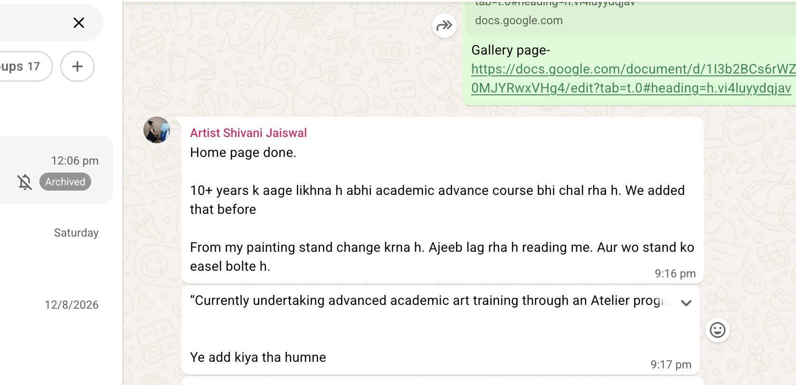

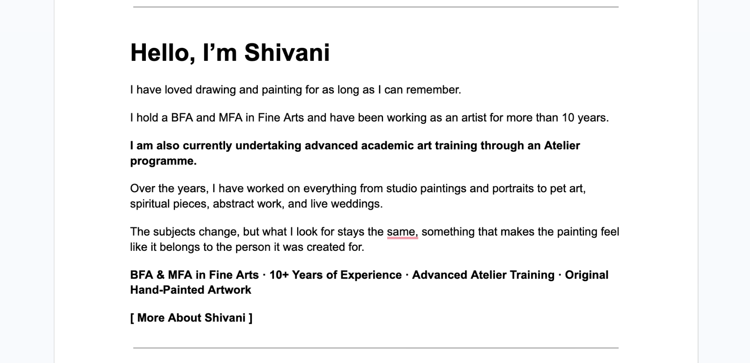

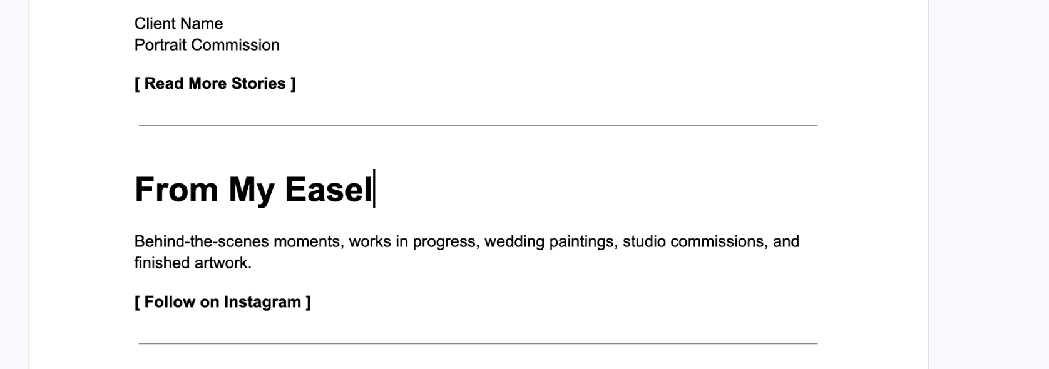

2. About Us

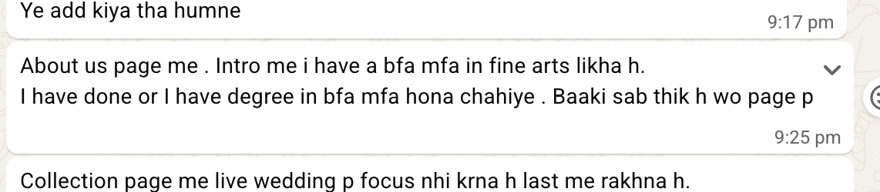

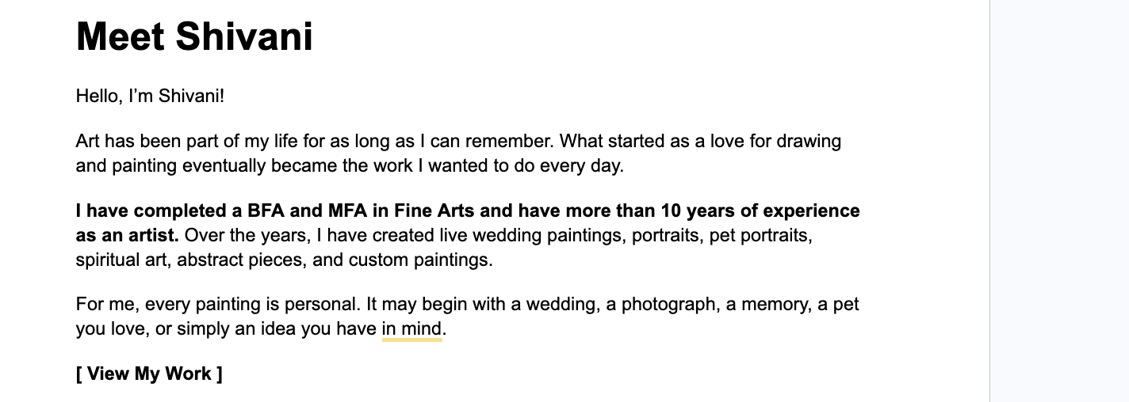

3. Collection Page

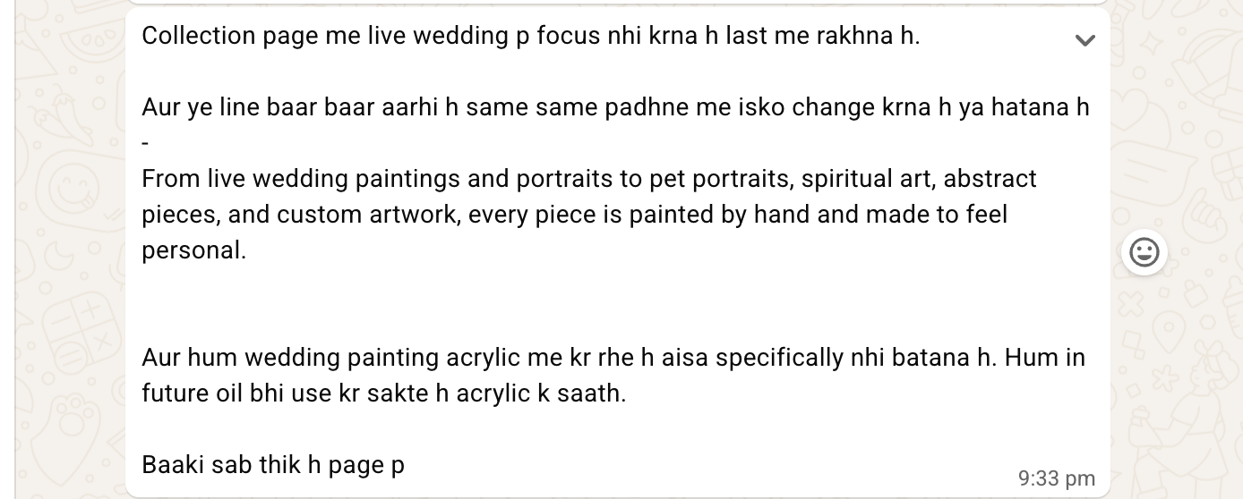

Replaced the repetitive opening line with: “Every piece is painted by hand, with the person, story, and space it is being created for in mind.”

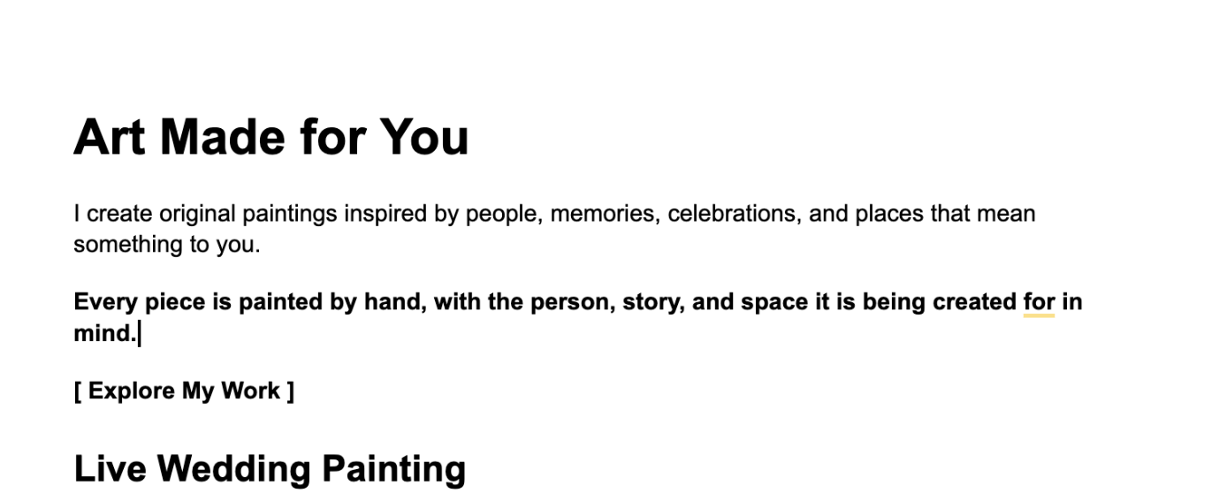

Removed the acrylic-only wording. It now says: “By the end of the celebration, your painting is complete and ready for the final reveal.”

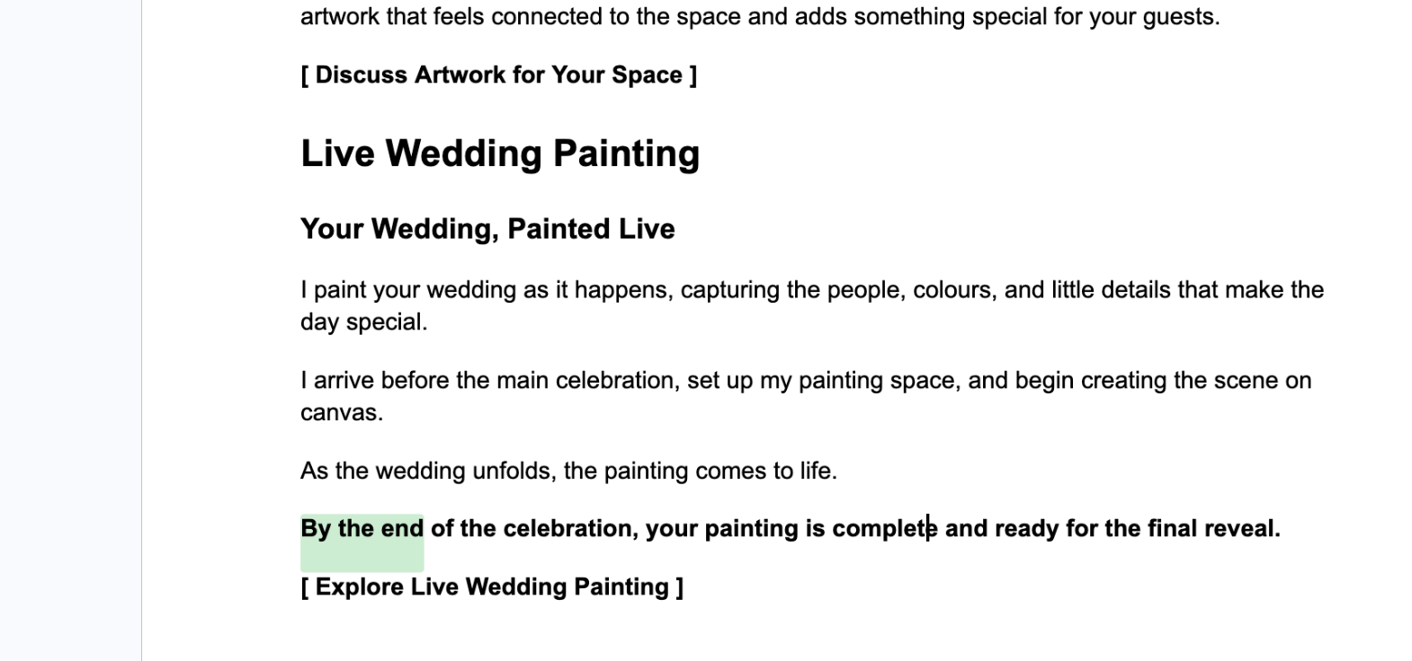

Live Wedding Painting moved to the end of the collection sections, so the page no longer leads with wedding content.
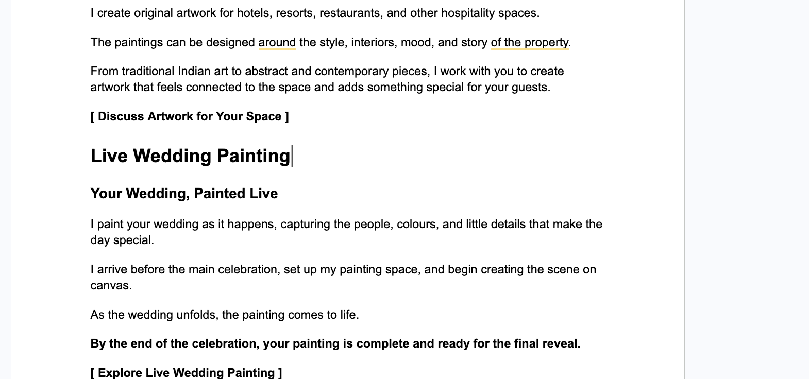

4. Live wedding painting live: https://docs.google.com/document/d/1N7loToCulpxMBhpqzSUFKuHpO7rXailmLu2QtCuSqfk/edit?tab=t.0#heading=h.nb7id7tigbh7

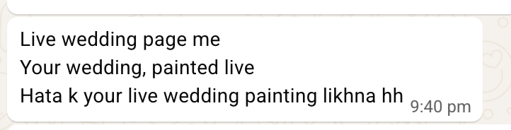

5. Gallery

